**ACTIONABLE INSIGHTS FOR AEROFIT**

*Drive Link:* [*https://drive.google.com/file/d/1B6t-1Kpa44vT3UHEXXSXilIVX7XnTlXD/view?usp=sharing*](https://drive.google.com/file/d/1B6t-1Kpa44vT3UHEXXSXilIVX7XnTlXD/view?usp=sharing)

1. Gender-specific marketing: Females prefer to buy beginner and intermediate equipments, KP281 and KP481 whereas only 9.21% females buy KP781. Therefore, Aerofit can **make KP281 and KP481 even more appealing to the females so that their sales boost even further**. For example, changing the **aesthetics** of beginner equipment to make it more appealing to the female customer base. Moreover, KP781 is bought by only 9.21% females. **Their sales can be boosted among females by keeping targeted discount offers (for example, on Mother’s Day, Daughter’s Day, etc.).**

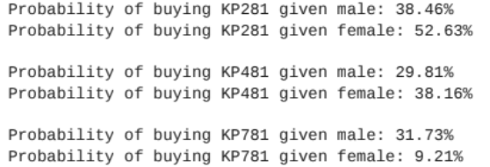

1. Customers who are partnered have a higher probability of approximately 59.44% of making a purchase, as opposed to single customers with a probability of 40.56%. The higher probability for partnered customers might indicate that **marketing strategies targeted at partnered individuals could be effective in driving purchases**.

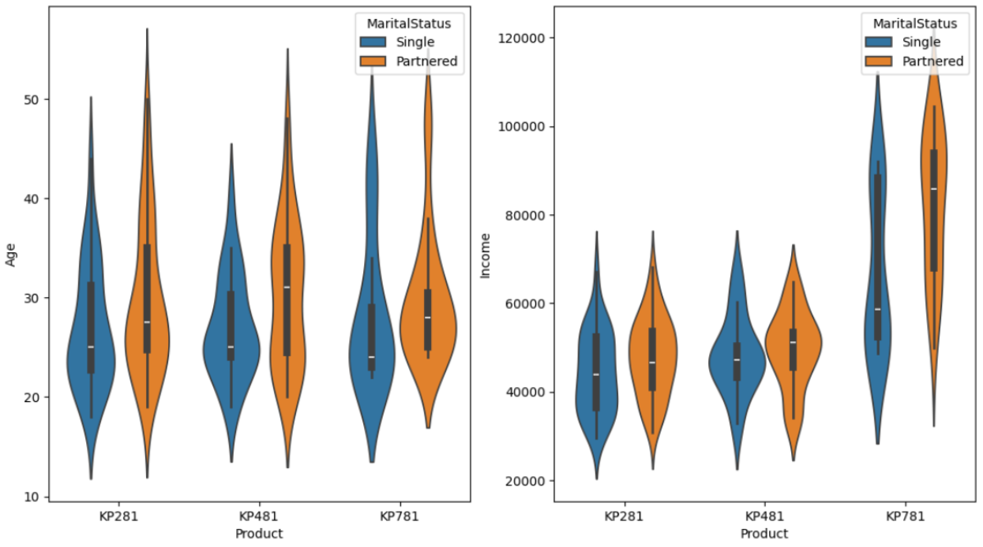

1. Approximately **24.44%** of the individuals in the dataset exhibit **both high fitness and high usage**. Advertising features that appeal to fitness enthusiasts can further drive the marketing campaign for this target audience of fitness enthusiasts. Heatmap also supports this data that there is a strong correlation between fitness and usage.

